MINOR FOOTBALL REGISTRATION NOW OPEN!!!
Football New Brunswick (FNB) is excited to announce it will be offering another football program this Spring in the Western Valley Region to children born between 2000-2005! The age groups will be separated into Under 12, Under 14 and Under 16 leagues.
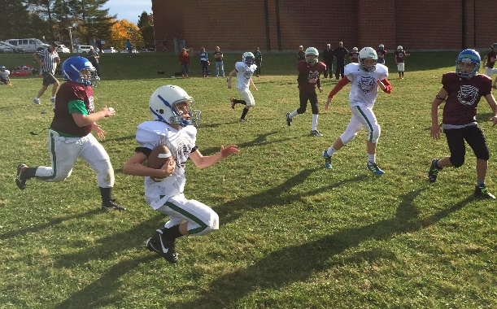
When: Teams will play 3 times a week throughout the month of May
What: It will include 2 hour practices and 2 jamborees!
Where: The football will be played at the Woodstock High School Rugby Field, but it is encouraged that residents from surrounding communities participate.
Cost: The cost to participate is only $75! This covers your child’s equipment rental, insurance, registration, 2 jamborees and a t-shirt!
Registration is now open on the Football New Brunswick homepage – www.footballnewbrunswick.nb.ca
Deadline to register is May 6th, 2015
An email will be circulated to those who register regarding equipment pick up
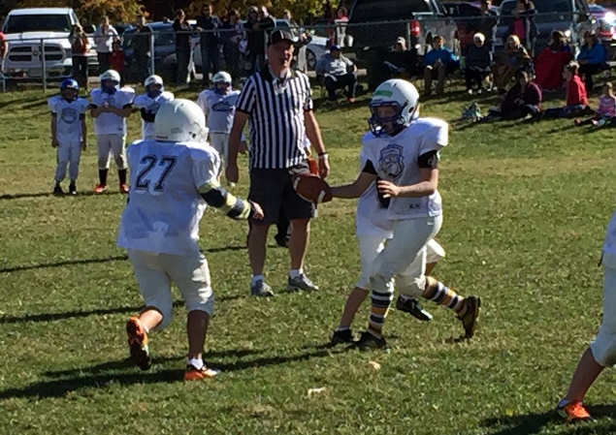
Please contact Josh Harris if you have any questions about the program, registering your child or how you can get involved!

Football New Brunswick Contact Information
Josh Harris,
Executive Director, Football New Brunswick
Email: ExecutiveDirector@FootballNB.ca
Phone: (506) 260-2993

ABOUT FOOTBALL NEW BRUNSWICK
Football New Brunswick is the recognized Provincial Sport Organization (PSO) for Tackle, Flag and Touch Football in the Province of New Brunswick. Their mission is to promote and aid the development and growth of fun and safe tackle, flag and touch football, in the Province of New Brunswick, for all age groups and both genders.

